**Fall 2023: CS5720**

**Neural Networks & Deep Learning - ICP-4**

**UDAY KUMAR KAMASANI**

**700738157**

1. **Data Manipulation**

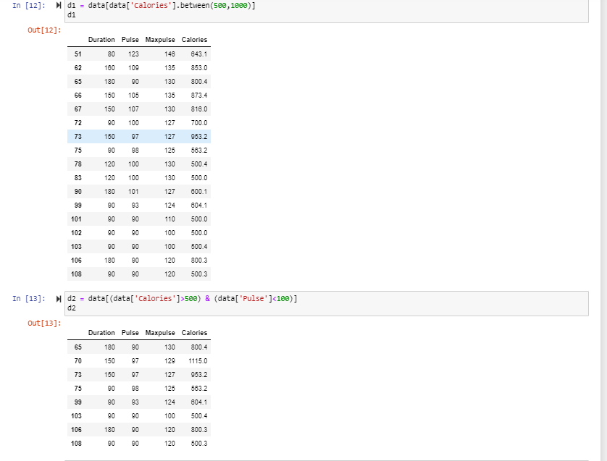

**2. Linear Regression**

**a) Import the given “Salary_Data.csv”**

**b) Split the data in train_test partitions, such that 1/3 of the data is reserved as test subset.**

**c) Train and predict the model.**

**d) Calculate the mean_squared error**

**e) Visualize both train and test data using scatter plot.**

